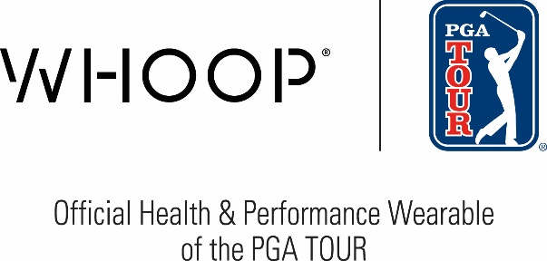

FOR RELEASE: February 25, 2026
CONTACTS: Justin Johns, PGA TOUR, justinjohns@pgatourhq.com
Pippa Doye, WHOOP, press@whoop.com

PGA TOUR, WHOOP extend official partnership through 2028
WHOOP continues as Official Health & Performance Wearable of the PGA TOUR

PONTE VEDRA BEACH, Florida – The PGA TOUR and WHOOP, the human performance company, today announced an extension of their Official Marketing Partnership. The new agreement continues the WHOOP designation as the Official Health & Performance Wearable of the PGA TOUR and PGA TOUR Champions through 2028.

As part of the agreement, WHOOP will continue to provide PGA TOUR, PGA TOUR Champions and Korn Ferry Tour players and trainers with the latest products and technology to assist in monitoring their health. WHOOP will also make their newest health service, WHOOP Advanced Labs, available to all PGA TOUR, PGA TOUR Champions and Korn Ferry Tour members, providing insights from 65 biomarkers combined with thousands of daily WHOOP data points for the most complete view of your health. WHOOP will also continue to have an onsite presence at all PGA TOUR events, through integration in the PGA TOUR’s Player Performance Center, which travels with the TOUR throughout the year.

“We are grateful for our continued relationship with WHOOP, which provides TOUR athletes with valuable health technology to help optimize the way they train, recover and sleep,” said Dan Glod, PGA TOUR Executive Vice President, Corporate Partnerships. “The WHOOP Strap offers our athletes critical physiological data that will help them to better prepare their bodies for competition across a rigorous season of competition on the PGA TOUR.”

WHOOP began its official partnership with the TOUR in 2021 after its health monitoring system proved critical in the PGA TOUR’s return to golf following the pandemic. During that time, more than 1,000 WHOOP Straps were distributed to players, caddies and other essential personnel at PGA TOUR, PGA TOUR Champions and Korn Ferry Tour events as the TOUR made a safe and responsible return to competition.

“We’re proud to extend our partnership with the PGA TOUR and continue supporting the world’s best golfers with the health and performance insights they need to live and compete at their peak,” said John Sullivan, Chief Marketing Officer at WHOOP. “Since 2021, WHOOP has played an important role in helping athletes monitor recovery, manage strain and optimize sleep across a demanding global schedule. We’re now expanding our health offering with WHOOP Advanced Labs, giving golfers an even clearer, more comprehensive picture of their health through deeper biomarker insights. As we look ahead to 2028, we’re excited to deepen our integration through WHOOP Live and bring fans closer to the game by showcasing real-time performance data during defining moments throughout the season.”

The renewed partnership will also include WHOOP Live and player insights across World Feed broadcasts, which highlights player biometric data during defining moments throughout the season with real-time metrics integrated into the broadcast. Originating from the TOUR’s new content facility – PGA TOUR Studios – the World Feed provides fans with more customized coverage and storytelling of the TOUR’s international players, complemented by a customized graphics package and a dedicated international commentary team.

###
About PGA TOUR
By showcasing golf’s greatest players, the PGA TOUR engages, inspires and positively impacts our fans, partners and communities worldwide.

The PGA TOUR, headquartered in Ponte Vedra Beach, Florida, co-sanctions events on the PGA TOUR, PGA TOUR Champions, Korn Ferry Tour, PGA TOUR Americas and administers PGA TOUR Q-School presented by Korn Ferry and PGA TOUR University. PGA TOUR members represent the world’s best players, hailing from 28 countries and territories. Showcasing the biggest moments in the sport with history and legacy on the line, the PGA TOUR operates PGA TOUR Studios–a state-of-the-art production studio redefining golf content for fans worldwide—and has long-term domestic distribution partnerships for broadcast coverage on CBS, NBC and Golf Channel, with video streaming service on ESPN+ and additional coverage on multiple Free Ad-Supported Television (FAST) channels. Internationally, the PGA TOUR Studios-produced World Feed is available across 200+ countries and territories in 30 languages via 39 broadcast and digital partners. To date, events across all Tours have generated more than $4 billion in charitable giving. Fans can follow the PGA TOUR at PGATOUR.COM, on the app and in multiple languages across their favorite social media pages.

About WHOOP
WHOOP, the human performance company, empowers people to unlock their potential and live longer, healthier lives. The WHOOP membership delivers world-class wearable technology, personalized coaching, and actionable insights across recovery, sleep, training, and health.

WHOOP wearable devices, including WHOOP 5.0 and WHOOP MG, feature groundbreaking innovations such as cardiovascular health screening (including an FDA-cleared ECG), Healthspan to measure Pace of Aging and WHOOP Age, and the first-of-its-kind wearable Blood Pressure Insights.
Founded in 2012 and headquartered in Boston, WHOOP has raised more than $400 million in venture capital and ships to 56 markets worldwide. To learn more or start a one-month free trial, visit whoop.com and connect with WHOOP on Instagram, X, Facebook, LinkedIn, and YouTube.

